**About Speakers,**

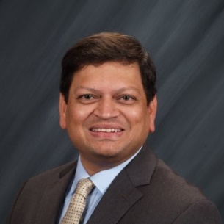**Sandeep Joshi** is the Director of Asia Technology Innovation Center at John Deere. He has been with John Deere for the last 10 years. During this time, he has held leadership roles in business and operations, including heading the Intelligent Solutions Group – Torrance business unit in California. Prior to joining Deere, Sandeep worked in a variety of functions like engineering services, application engineering, marketing, and innovation consulting with MSC Software Corporation (now part of Hexagon AB) and Invention Machine (now part of IHS Markit).

Sandeep has an M.B.A. from UCLA Anderson School of Management, Los Angeles, California, USA. He has an M.S. in Mechanical Engineering from Clemson University, Clemson, South Carolina, USA, and a B.E. in Mechanical Engineering from College of Engineering, University of Poona, India. He is currently serving as Regional Manager ( Asia and Africa) in Training Delivery Function in John Deere Earlier worked as Research Associate with IIT, Bombay

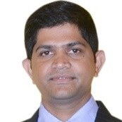

**Dinesh Phatak** is a senior Technical specialist responsible for advanced Embedded systems team. Dinesh has over 15 years experience in Embedded Systems area & he has been working with John Deere over 11 years. Dinesh has bachelors degree in Electronics & telecommunications & executive diploma in business management. In his current role driving advanced capabilities in the areas of sensing & perception engineering.

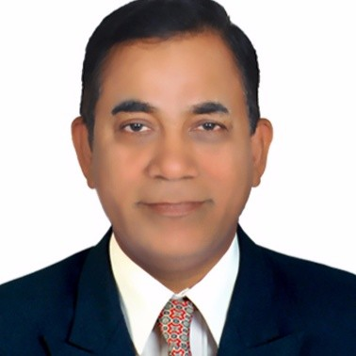**Chandrakant Turare** obtained M.Tech degree in Farm Power and Machinery from IIT, Kharagpur M.S. in Appropriate Technology and Management from University of Flensburg, Germany Executive MBA from Symbiosis Institute of Business Management

He worked mainly in area of technical information services, global training development and delivery learning technologies including learning management system, mobile learning He is very much passionate for development of agro technologies , Improving quality of education and developing students talent.